**Cooperation agreement signed with France, Greece and Romania**

**11Jun**2019

The Directors of the French, Greek and Romanian National Safety Authorities and ERA’s Executive Director, Josef Doppelbauer signed the cooperation agreements.

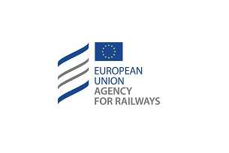

After the cooperation agreement [signed with the Italian National Safety Authority](https://www.era.europa.eu/content/signature-cooperation-agreement-italy_en), ERA’s Executive Director, Josef Doppelbauer, has signed the cooperation agreements with the National Safety Authorities of France, Greece and Romania.

The ceremony took place in Bucharest at the International Railway Conference, an event organised in the scope of the Romanian presidency of the EU council. This is another step towards the full implementation of the new EU railway regulatory framework, in fact the cooperation agreements aim to establish the conditions under which the different authorities are expected to cooperate in relation to their tasks of issuing single safety certificates, vehicle and vehicle type authorisations, as well as the framework for providing assistance to ERA.